**<https://tpchd.org/healthy-places/food-safety/>**

[**Home**](https://tpchd.org/)**»**[**Healthy Places**](https://tpchd.org/healthy-places/)**» Food Safety**

**Food Safety**

**Inspection Rating Signs**

Look out for the signs in restaurants, grocery stores, and any other place that serves food.

[Learn more](https://tpchd.org/healthy-places/food-safety/inspection-rating/)

**Food Bites Newsletter**

Check out the latest edition about code changes, rating signs and more!

[Read latest edition](https://tpchd.org/healthy-places/food-safety/existing-food-businesses/food-bites-newsletter/)

**Inspection Rating Signs**

Look out for the signs in restaurants, grocery stores, and any other place that serves food.

[Learn more](https://tpchd.org/healthy-places/food-safety/inspection-rating/)

**Food Bites Newsletter**

Check out the latest edition about code changes, rating signs and more!

[Read latest edition](https://tpchd.org/healthy-places/food-safety/existing-food-businesses/food-bites-newsletter/)

**Inspection Rating Signs**

Look out for the signs in restaurants, grocery stores, and any other place that serves food.

[Learn more](https://tpchd.org/healthy-places/food-safety/inspection-rating/)

**Food Bites Newsletter**

Check out the latest edition about code changes, rating signs and more!

[Read latest edition](https://tpchd.org/healthy-places/food-safety/existing-food-businesses/food-bites-newsletter/)

Previous slide

Next slide

[**Food Worker Card**](https://tpchd.org/healthy-places/food-safety/food-worker-card/)

[**Inspection Rating**](https://tpchd.org/healthy-places/food-safety/inspection-rating/)

[**Restaurant Inspections**](https://tpchd.org/healthy-places/food-safety/restaurant-inspections/)

[**Food Closures**](https://tpchd.org/healthy-places/food-safety/food-establishment-closures/)

[**Report a Food Concern**](https://tpchd.org/healthy-places/food-safety/report-foodborne-illness-or-food-safety-complaint/)

**Dine out with confidence.**

When you eat, you shouldn’t have to worry about getting sick. That’s why we work to make sure your food is safe to eat. We work with food handlers, restaurants and businesses to prevent foodborne illness.

**We:**

* Teach and certify people to safely serve food.
* Inspect and teach to make sure food is safely stored, handled, cooked and served.
* Investigate foodborne illness outbreaks.

**Questions?**

Email [food@tpchd.org](mailto:food@tpchd.org) or call:

* **General**—(253) 649-1417
* **Plan Review**—(253) 649-1706
* **Food Worker Card**—(253) 649-1416

You can also drop in or call to schedule an in-person appointment. We’re open Monday through Friday from 8 a.m. to 4 p.m. But, close from noon to 1 p.m. for lunch. We accept applications until 4 p.m.

**Information for:**

[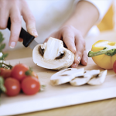](https://tpchd.org/healthy-people/food-safety-for-consumers/)

[**Consumers**](https://tpchd.org/healthy-people/food-safety-for-consumers/)

[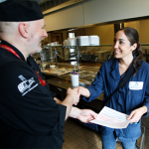](https://tpchd.org/healthy-places/food-safety/opening-a-food-business/)

[**New Businesses or Owners**](https://tpchd.org/healthy-places/food-safety/opening-a-food-business/)

[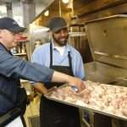](https://tpchd.org/healthy-places/food-safety/existing-food-businesses/)

[**Existing Businesses**](https://tpchd.org/healthy-places/food-safety/existing-food-businesses/)

[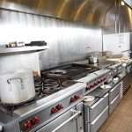](https://tpchd.org/healthy-places/food-safety/commissary-kitchens/)

[**Commissary Kitchens**](https://tpchd.org/healthy-places/food-safety/commissary-kitchens/)

[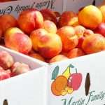](https://tpchd.org/healthy-places/food-safety/farmers-markets/)

[**Farmers Markets**](https://tpchd.org/healthy-places/food-safety/farmers-markets/)

[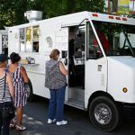](https://tpchd.org/healthy-places/food-safety/mobile-food-units/)

[**Mobile Food Units**](https://tpchd.org/healthy-places/food-safety/mobile-food-units/)

[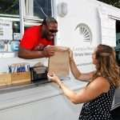](https://tpchd.org/healthy-places/food-safety/temporary-events/)

[**Temporary Events**](https://tpchd.org/healthy-places/food-safety/temporary-events/)

**Learn more**

* [Fee schedule](https://tpchd.org/i-want-to/about-us/fee-schedule/).
* [Handwashing.](https://tpchd.org/healthy-people/handwashing/)
* [Food Advisory Board.](https://tpchd.org/healthy-places/food-safety/food-advisory-board/)
* [Donate food safely](https://tpchd.org/healthy-places/food-safety/donate-food-safely/).
* [Printable food safety materials.](https://tpchd.org/healthy-places/food-safety/food-safety-materials/)